Playground Loch Lomond School
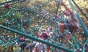
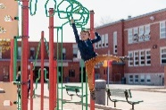
Playground Boundaries
This Photo by Unknown Author is licensed under CC BY-SA-NC
Roary’s Prideland

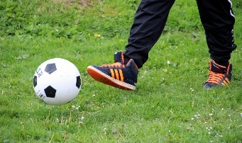

- All students are to go outside at recess and lunch break. During cold or wet weather, students will remain
inside.

2.) Students will respect others, their property and personal belongings.

3) Some equipment will be closed in the winter (including the hang glider) due to icy conditions

4) In the winter, students must slide down hills on their bum in ski pants and should remain off icy surfaces or
snowbanks

5) General playground rules

- Keep your hands and feet to yourself
- Play safely on the equipment
- Use appropriate language
- Take turns
- Respect the playground boundaries and ask permission if you need to go out of bounds
- Rocks, apples, and snowballs stay on the ground
- Include others in your games
- Climb UP the Rock Wall
- Slide DOWN the slides only and move away quickly once down.
- Keep lines moving on the equipment.
- Play on it – only if you can reach it
- The spider net and monkey bars are used for swinging / climbing only.
- Tag games are to be played in the field, bus turn around or at safe distance from the equipment.
- Balls are for the field or pavement

6) When lined up, quiet students will enter the school in an orderly fashion.

